Introduction

What it does

This tool permits a series of tests to be written addressing specific tags or entry points within a project and act to verify that the return results are as expected for that code. The significance of this is that, when run routinely any time that the project is modified, it will act to indicate whether the intended function has been modified inadvertently or whether the modification has had unexpected effects on other functionality within the project. The set of unit tests for a project should run rapidly (usually within a matter of seconds) and with minimal disruption for developers. Another function of unit tests is that they indicate what the intended software was written to do. The latter may be especially useful when new developers start working with the software or a programmer returns to a project after a prolonged period.

The concept of Unit Testing was already in place before Kent Beck created a tool that he used in the language Smalltalk, and then was turned into the tool Junit for Java by Kent Beck and Erich Gamma. This tool for running specific tests on facets of a software project was subsequently referred to as xUnit, since NUnit was developed for .NET developers, DUnit for Delphi developers, etc. MUnit is the equivalent tool for M developers to use and was originally created in 2003.

Using M-Unit

The M-Unit functionality is contained in the %ut and %ut1 routines. The code was originally written by Joel Ivey when he was working as a developer for the Department of Veteran Affairs. The code had input as suggestions by several other developers both inside and outside of the VA, including Kevin Meldrum and especially Sam Habiel who made significant contributions to the current status. Current development is being continued for OSHERA via VistA Expertise Network.

%ut ;VEN-SMH/JLI - PRIMARY PROGRAM FOR M-UNIT TESTING ; 08/04/14 16:13

;;0.1;MASH UTILITIES;

; This routine and its companion, %ut1, provide the basic functionality for

; running unit tests on parts of M programs either at the command line level

; or via the M-Unit GUI application for windows operating systems.

From a user’s perspective the basic start for unit tests from the command line is the entry point EN^%ut, the first argument is the name of the routine to be tested and is required, but the tag can take up to two additional arguments: a verbose indicator and a BREAK indicator, both of these require a non-zero value to activate them.

D EN^%ut(“ROUTINE_NAME”)

or

D EN^%ut(“ROUTINE_NAME,VERBOSE,BREAK)

The command with a single argument will result in the unit tests being run and each successful test is shown by a period (‘.’) followed by specification of the number of tags entered, the number of tests run, the number of failures, and the number of errors encountered. Instead of the period for successes, failures or errors are indicated by the tag and routine name for the specific test, a description of the test if provided, and a message concerning the failure if provided or the line and routine at which the error occurred. The verbose option will result in a listing of each test that is executed, which may make it more difficult to identify problems if they have occurred. The BREAK option will result in termination of the unit test as soon as a failure or error is encountered.

The code written in a unit test routine has specific entry points that should indicate a specific set of functionality being tested. The tag may have more than one test, but these should all focus on the same aspect being tested. Originally specification of the tags and a description of the functionality being tested by the tag testing were entered following an XTENT tag in the following manner.

XTENT ;

;;TEST1;Testing functionality for one feature

;;ANEW1;Testing another piece of functionality

;;ATHIRD;Testing still something else

More recently, an alternative method was added similar to the annotation used in C#, thanks to the suggestion of Kevin Meldrum. The indicator @TEST is specified as the first string following the semi-colon on the same line as the tag, and a description can then be added following this indicator.

TEST4 ; @TEST another test for different functionality

Since there will frequently be multiple routines with tests created to test a specific project, these can be indicated in a manner similar to the original description of the entry tags, following a XTROU tag. The following could be used to link additional test routines to a ZZUXQA1 test routine.

XTROU ;

;;ZZUXQA2

;;ZZUXQA3

;;ZZUXQA4

The other routines can also reference these as well, or additional related test routines. Each routine would be included only once, no matter how many of the other routines reference it.

A test routine can use one of three types of calls for its tests, determining truth, equivalence, or simply indicating failure for the test. In each of these a final argument can be used to specify information about the specific test result.

Truth is tested by the command

DO CHKTF^%ut(TorF,message)

where ‘TorF’ is a value to be tested for true (passing the test) or false (failing the test).

Equivalence is tested by the command

DO CHKEQ^%ut(expected,result,message)

where ‘expected’ is the value that is expected from the test, and ‘result’ is the value that was obtained and should be equal to ‘expected’ if the test is to pass.

Failure already determined is specified by the command

DO FAIL^%ut(message)

and is generally used when the processing has reached an area that it shouldn’t be expected to reach given the circumstances, and ‘message’ then describes the situation.

The MUnit functionality is set up to capture information on errors, and to continue processing the remaining tests within the tag as well as additional tags.

There are four other tags that have meaning to the MUnit functionality - STARTUP, SETUP, TEARDOWN, and SHUTDOWN. Frequently, to provide specific data to use for testing, it may be necessary to add data which is totally temporary, either for all tests in one pass, or before each test is run.

The STARTUP tag specifies code that should be run once when the testing is starting up. At most only a single STARTUP tag should be present in a tests for a given project. Its companion is SHUTDOWN, which if present, will be run only after all of the tests have been completed. Again, there should only be a single SHUTDOWN tag in a project.

The SETUP tag specifies code that should be run before each test tag in a given routine is run, there could be similar SETUP tags in other routines as well. Its companion is TEARDOWN which, if present, will be run immediately after each test tag is processed.

It should be noted that care should be taken in using these four tags, since they may end up hiding significant functionality from testing or result in problems later if changes are made to the tests (which would then be converted into changes in the project related to the tests).

An additional tag (CHKLEAKS^%ut) is available for checking for variable leaks either as a part of a unit test, or it can be called outside of unit tests as well.

CHKLEAKS(%zuCODE,%zuLOC,%zuINPT) ; functionality to check for variable leaks on

executing a section of code

; %zuCODE - A string that specifies the code that is to be XECUTED and checked for leaks.

; this should be a complete piece of code

; (e.g., "S X=$$NEW^XLFDT()" or "D EN^%ut(""ROUNAME"")")

; %zuLOC - A string that is used to indicate the code tested for variable leaks

; %zuINPT - An optional variable which may be passed by reference. This may

; be used to pass any variable values, etc. into the code to be

; XECUTED. In this case, set the subscript to the variable name and the

; value of the subscripted variable to the desired value of the subscript.

; e.g., (using NAME as my current namespace)

; S CODE="S %zuINPT=$$ENTRY^ROUTINE(ZZVALUE1,ZZVALUE2)"

; S NAMELOC="ENTRY^ROUTINE leak test" (or simply "ENTRY^ROUTINE")

; S NAMEINPT("ZZVALUE1")=ZZVALUE1

; S NAMEINPT("ZZVALUE2")=ZZVALUE2

; D CHKLEAKS^%ut(CODE,NAMELOC,.NAMEINPT)

;

; If part of a unit test, any leaked variables in ENTRY^ROUTINE which result

; from running the code with the variables indicated will be shown as FAILUREs.

;

; If called outside of a unit test, any leaked variables will be printed to the

; current device.

;

The GUI MUnit application provides a visually interactive rapid method for running unit tests on M code.

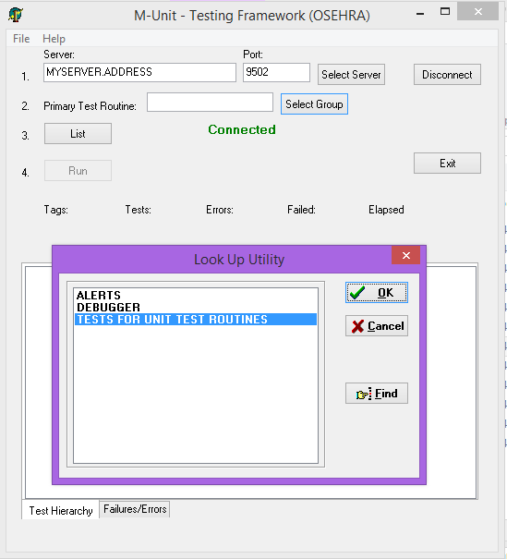

Figure 1. Selection of an M-Unit test

After specifying the server address and port, the user can sign on or click the Select Group button to select a unit test from the M-UNIT TEST GROUP file (#17.9001) as shown here (Figure 1), or simply enter the name of a unit test routine in the Primary Test Routine field and click on List. This will bring up a list of the routines and tags in the unit test run (Figure 2).

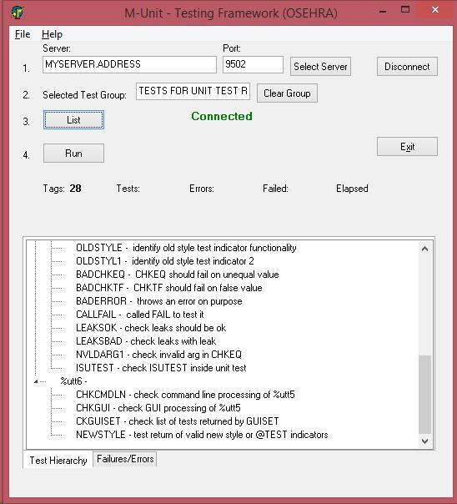

Figure 2. List of Unit tests selected for running

Clicking the Run button will run the unit tests, resulting in a bar which is green if all tests pass or red if any failures or errors are encountered (Figure 3).

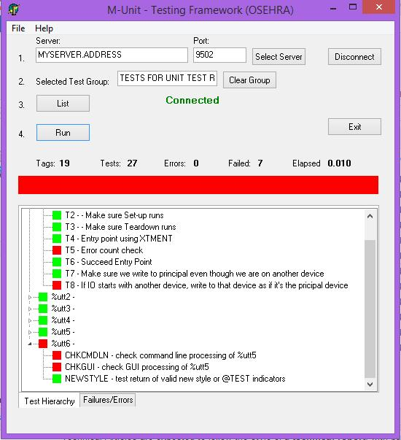

Figure 3. The unit tests run with failures

If failures or errors are encountered, clicking on the Failures/Errors tab at the bottom of the listing opens a display of specific information on the problems.

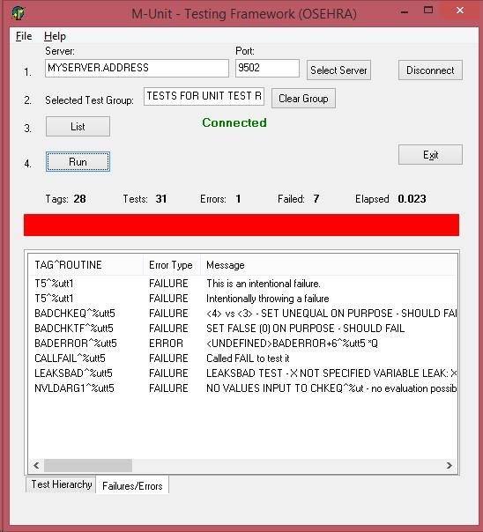

Figure 4. Specifics on failed tests or errors

In the case shown (Figure 4), all of the failures are intentional. Usually, failures and/or errors are not intentional and the user can then edit the routine, and save the changes, then simply click on the Run button again to see the effect of the changes.

To select a new unit test, the user would click on the Clear Group button, then again either select another group or as shown in Figure 5, entering the name of a unit test routine (ZZUXQA1 and related routines are not included with the M-Unit Test code and is shown only as an example) and clicking on the List button.

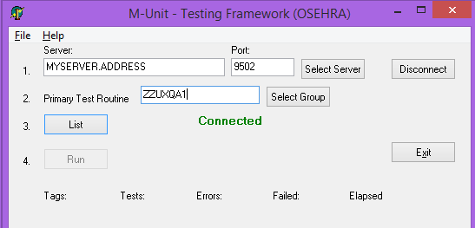

Figure 5. Specification of unit tests by routine name

Again, clicking the Run button will run the unit tests (Figure 6). This figure shows the desired result, a green bar meaning that all tests passed.

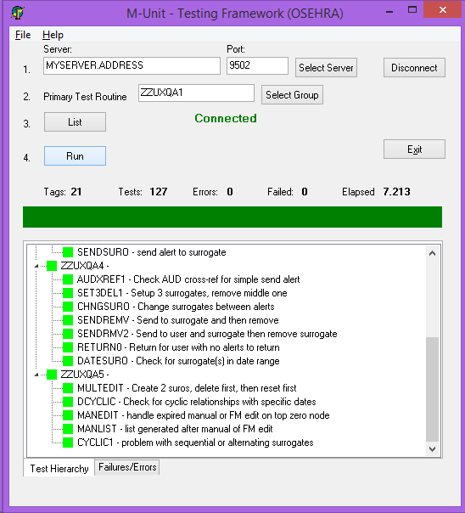

Figure 6. Result from the second group of unit tests

The results of both of these groups of tests (%utt1 and ZZUXQA1 and their related routines) run at the command line using are shown in Figure 7.

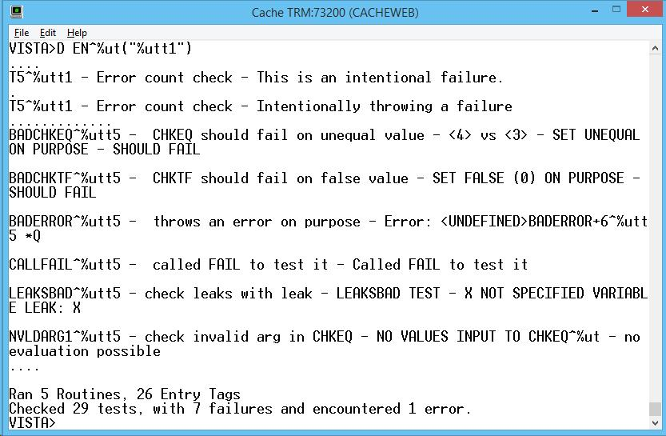

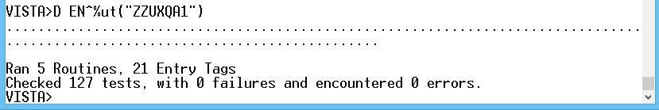

Figure 7. Command line unit tests for %utt1

The results of the single %utt1 unit test routine (and its related routines) run with the VERBOSE option, that some people prefer, specified permits the individual tests and their results to be seen, but makes the results more difficult to interpret (Figure 8).

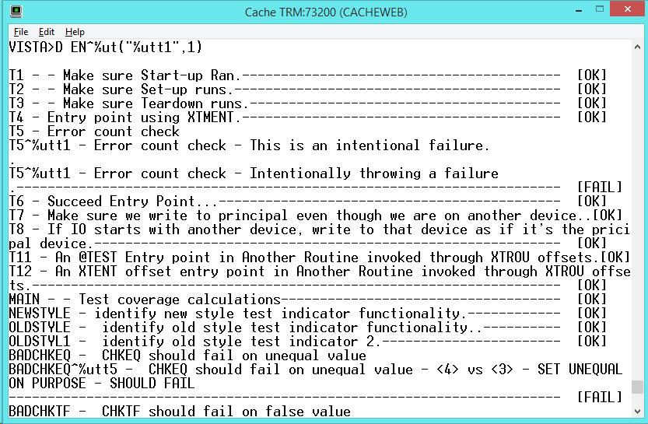

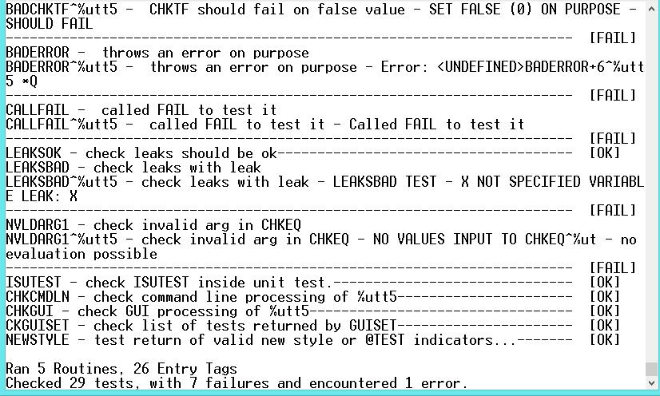

Figure 8. Command line unit tests for %utt1 with VERBOSE option

On-going/Future plans for M-Unit functionality:

As a unique program in the realm of M[UMPS] code testing but following in the footsteps of other well established unit test frameworks, the M-Unit software will continue to move forward and improve (as the @TEST indicator was added based on changes in NUnit and JUnit).  M-Unit will likely branch out and expand the types of checks that are available, matching the functions of other established test beds.

Summary

M-Unit provides a tool which can assist in writing and modifying routines in M projects with an aim to minimizing flaws in development and in the ongoing life of the software.